Final Report/ Manual
Group 22
Team Members: Bader AlKhawashki, Fritz Kuermayr, Salvador Gonzalez, Arunima Basu

Compile a “Manual” for your fully integrated device, such that another engineer could replicate, and even iterate upon, your project.

Opportunity:
For farmers/gardeners who own greenhouses, it’s a robot that detects local humidity within a greenhouse, and if it falls below a certain threshold (detected using analog and digital sensors), the robot humidifies the area using water mist and moves around the greenhouse to ensure proper humidification of the entire area.

High-level strategy:
Our GreenBot continuously monitors key greenhouse humidity conditions. When values drift outside target ranges, it automatically triggers the correct response (humidification).

Discussion of Initial and achieved specifications:
Discuss/compare your initial desired functionality to your achieved
specifications (e.g., we wanted to drive at least 1 foot per second and achieved a maximum speed
of 0.95 feet per second).

- A photo showing the integrated physical device, fully assembled and with labels showing where
actuators and sensors are located and highlighting any moving parts/joints. You can include a
couple views to show key subsystems as needed. Think of this diagram as a “key” of terms that
you can use in your description (e.g., “the wheel transmission...” highlight in the image what this
means to you).

Discussion of function-critical decisions and calculations.

1. Mass and Load Estimations
The total mass of the quadruped robot is estimated at approximately 2 kg, which is derived
from the main components. The eight Dynamixel RX-24F actuators contribute roughly 0.66
kg. The Raspberry Pi, OpenBCI Cyton board, and other electronics add about 0.1 kg,
and the 12 V 5000 mAh battery weighs approximately 0.35 kg. The structural components,
including the 3D-printed chassis and legs, are estimated at 0.5 kg, while the active water
payload adds about 0.3 kg.
Consequently, the total weight force acting on the robot’s center of mass is approximately
20 N. During locomotion, it is assumed as a worst-case scenario that only two legs support
the entire weight of the robot during parts of the gait cycle. Therefore, a single active leg
must support roughly 10 N of vertical static load.
2. Actuator Torque Analysis
The worst-case mechanical stress on the transmission occurs when the leg is fully extended
outward. This configuration creates the largest lever arm relative to the motor axis.
• Lever Arm: The leg length is 32 mm (0.032 m).
• Maximum Torque: The 10 N vertical load produces a resultant worst-case torque
at the motor of roughly 0.31 Nm.
The Dynamixel RX-24F actuator specified for the joints possesses a maximum stall torque
of approximately 2.6 Nm at 12 V. Because the estimated required torque of 0.31 Nm is
significantly lower than the maximum capability of the actuator, the design features a large
safety margin.
3. Bearing Load Standards (ABMA)
The primary load on the robot leg acts through the structure as a lever, transmitting forces
directly into the joints and bearings. The leg assembly utilizes 16 press-fit ball bearings to
support the rotational joints.
To verify the reliability of the transmission, the bearing loads were evaluated using American Bearing Manufacturers Association (ABMA) standards for deep-groove ball bearings.
The ABMA standard defines the effective combined bearing load using the following relationship:
Fe = (Xi· V · Fr) + (Yi· Fa)
Where:
• Fr is the radial load acting on the bearing
• Fa is the axial load
• V is a rotation factor (V = 1 when the inner ring rotates)
• Xi and Yi are radial and thrust load factors defined by the ABMA standard
In this design, the planar linkage introduces negligible axial load, therefore:
Fa = 0
The static load on a single leg is approximately 10 N. To account for dynamic walking
impacts and shocks, a conservative dynamic factor of 3 is applied. This results in a maximum
radial load of:
Fr = 30 N
Because Fa/C0 is below the ABMA limit value e, the standard coefficients are:
• Xi = 1.00
• Yi = 0
Substituting into the ABMA equation:
Fe = (1.00 · 1 · 30 N) + (0 · 0)
Fe = 30 N
Therefore, the effective bearing load is approximately 30 N in the worst-case dynamic
condition where all force is assumed to act on a single bearing.
This value remains significantly lower than the rated load capacity of standard miniature
deep-groove ball bearings such as the 638ZZ, confirming that the bearing operates safely
within its mechanical limits according to ABMA guidelines.

4. 3D-Printed Housing Tolerance Standards (ANSI)
The 16 ball bearings must be press-fit into the 3D-printed plastic upper and lower legs.
To achieve proper alignment without compromising the structural integrity of the additive
manufacturing layers, the interface relies on American National Standards Institute (ANSI)
limits and fits.
The theoretical CAD geometry was established around an ANSI H7/k6 locational transition fit. This standardized fit is an ideal compromise between clearance and interference
for accurate location.
However, standard locational interference fits (such as H7/p6) are designed for rigid
steel components and would cause the 3D-printed plastic to yield or delaminate under high
internal bore pressure. Therefore, the upper and lower fundamental deviations of the H7/k6
specification were adopted as a baseline, but light physical dimensional offsets were applied
during slicing to compensate for polymer creep and FDM resolution, ensuring a secure fit
that adheres to ANSI principles adapted for plastic housings.

State Diagrams:
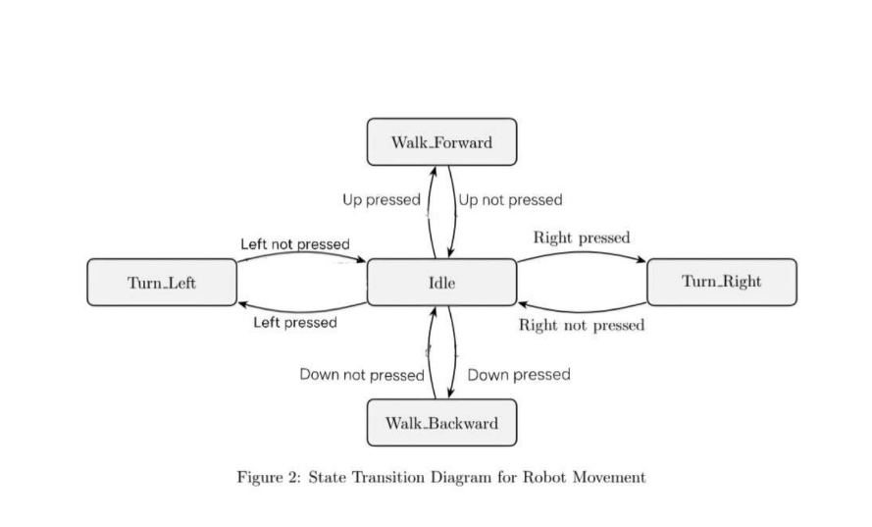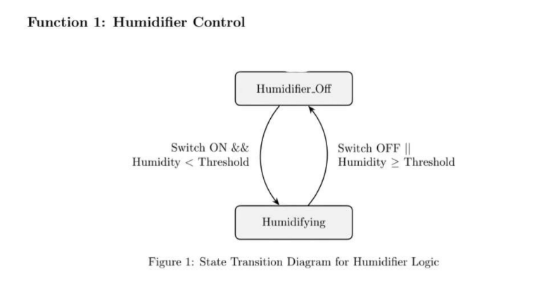
Reflection:
We recommend students buy spare parts in case of any issues, as one of our electronic parts had short-circuited; thankfully, we were able to fix the issue quickly using soldering, and all project deliverables were completed.

APPENDIX
o Complete Bill of Materials:
Section | Item | Qty | Cost/part (USD) | Subtotal
Upper Part | Humidity sensor | 1 | $0 | $0
Upper Part | Microcontroller (ESP32 Feather V2) | 1 | $0 | $0
Upper Part | Mister (pump + nozzle) | 1 | $10 | 10
Upper Part | Cables | 30 | $0 | $0
Upper Part | 3D-Printed Tank + Platform | 1 | $2 | $2
Upper Part | 3D Printed LED | 1 | $1 | $1
Lower Part | Upper legs (3D-printed) | 8 | $0.5 | $4
Lower Part | Lower legs (3D-printed) | 8 | $0.5 | $4
Lower Part | Ball bearings | 16 | $15 | $15
Lower Part | Chassis (3D-printed) | 1 | $5 | $5
Lower Part | Distance holder M2.5 (20 mm) | 6 | $0.15 | $1
Lower Part | Distance holder M2.5 (10 mm) | 6 | $0.15 | $1
Lower Part | Upper chassis (3-part print) | 1 | $2 | $2
Lower Part | Battery holder (3D-printed) | 1 | $1 | $1
Lower Part | Motor controller holder (3D-printed) | 1 | $1 | $1
Lower Part | Dynamixel RX-24F actuators | 8 | $0 | $0
Lower Part | 12V 5000mAh battery | 2 | $30 | $60
Lower Part | Raspberry Pi 4 | 1 | $75 | $75
Lower Part | Roboteck K4P | 9 | $20 | $180
Lower Part | USB-C to USB-B cable | 1 | $5 | $5
Lower Part | Diatone Mamba Micro 2A BEC | 1 | $4 | $4
Lower Part | U2D2 (USB-to-Serial) | 1 | $35 | $35
Lower Part | Arduino USB dongle | 1 | $10 | $10
Lower Part | Screws & Nuts | 20 | $5 | $5
Upper part | Washers | 10 | $5 | $5
Upper part | Fasteners | 10 | $0 | $0
Upper part | Gaskets | 10 | $0.5 | $5
Upper part | MOSFET | 1 | $15 | $15

o Images of the CAD, showing mechanical transmission elements.
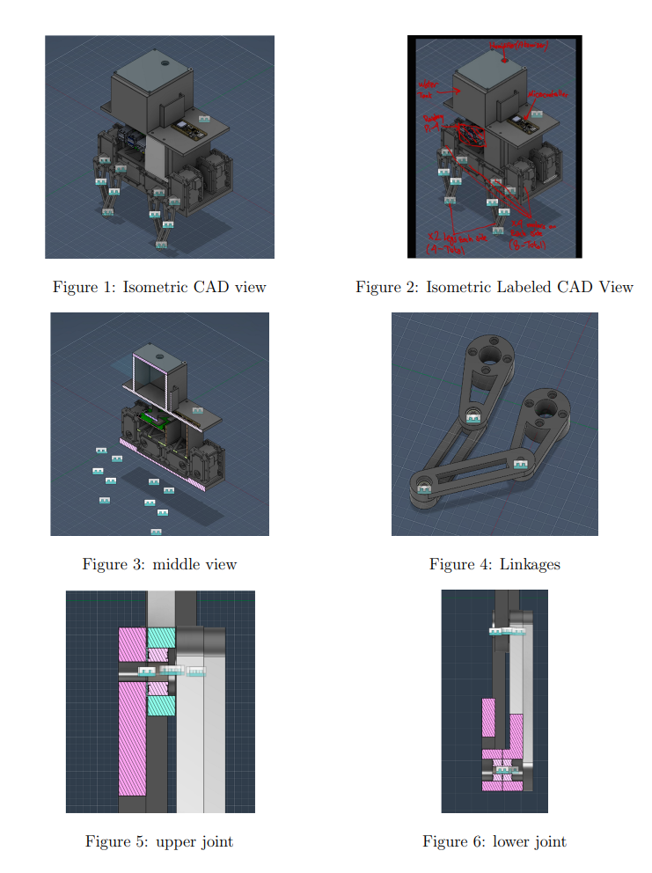

o Screen shots of your entire code, showing your event-driven program (most updated.)

Humidity Control Code:
1 from __future__ import annotations
2
3 import threading
4 import time
5 from dataclasses import dataclass
6 from typing import Optional
7
8 # Standard humidity - control c on fi gu ra ti on .
9 HUMIDITY_THRESHOLD = 45.0
10 SENSOR_POLL_INTERVAL_SEC = 2.0
11 HUMIDIFIER_GPIO = 17
12 ENABLE_SWITCH_GPIO = 27
13 I2C_SENSOR = " SHT40 on Raspberry Pi I2C1 : GPIO2 / SDA1 and GPIO3 / SCL1 "
14 SWITCH_DEBOUNCE_MS = 50
15
16
17 @dataclass ( frozen = True )
18 class HumidityControlConfig :
19 humidity_threshold : float = HUMIDITY_THRESHOLD
20 sensor_poll_interval_sec : float = SENSOR_POLL_INTERVAL_SEC
21 humidifier_gpio : int = HUMIDIFIER_GPIO
22 enable_switch_gpio : int = ENABLE_SWITCH_GPIO
23 switch_debounce_ms : int = SWITCH_DEBOUNCE_MS
24
25
26 class HumidityController :
27 """
28 Non - blocking SHT40 humidity controller for a MOSFET - switched humidifier .
29
30 The control loop runs in its own daemon thread . Any sensor read error or
31 disabled enable switch forces the humidifier GPIO low .
32 """
33
34 def __init__ ( self , config : Optional [ HumidityControlConfig ] = None ) -> None :
35 self . config = config or HumidityControlConfig ()
36 self . _stop_event = threading . Event ()
37 self . _thread : Optional [ threading . Thread ] = None
38 self . _humidifier_output = None
39 self . _enable_switch = None
40 self . _sensor = None
41
42 def start ( self ) -> None :
43 if self . _thread is not None :
44 return
45
46 try :
47 self . _setup_gpio ()
48 self . _humidifier_off ()
49 except Exception :
50 self . _humidifier_off ()
51 self . _close_gpio ()
52 raise
53
54 self . _thread = threading . Thread (
55 target = self . _loop , name =" humidity - control ", daemon = True
56 )
57 self . _thread . start ()
58 print (
59 "[ humidity ] started "
60 f" threshold ={ self . config . humidity_threshold :.1 f}% "
61 f" poll ={ self . config . sensor_poll_interval_sec :.1 f}s"
62 )
63
64 def stop ( self ) -> None :
65 self . _stop_event . set ()
66 if self . _thread is not None :
67 self . _thread . join (
68 timeout = max (1.0 , self . config . sensor_poll_interval_sec + 0.5)
69 )
70 self . _thread = None
71
72 self . _humidifier_off ()
73 self . _close_gpio ()
74 print ("[ humidity ] stopped ")
75
76 # STATE MACHINE DRIVER :
77 # Periodically runs the humidity - control state machine without blocking the
78 # quadruped movement loop .
79 def _loop ( self ) -> None :
80 while not self . _stop_event . is_set () :
81 self . _control_once ()
82 self . _stop_event . wait ( self . config . sensor_poll_interval_sec )
83
84 # STATE MACHINE TRANSITION LOGIC :
85 def _control_once ( self ) -> None :
86 if not self . _switch_enabled () :
87 self . _humidifier_off ()
88 return
89
90 humidity = self . _read_humidity ()
91 if humidity is None :
92 self . _humidifier_off ()
93 return
94
95 if humidity < self . config . humidity_threshold :
96 self . _humidifier_on ()
97 else :
98 self . _humidifier_off ()
99
100 # SERVICE FUNCTION :
101 def _setup_gpio ( self ) -> None :
102 try :
103 from gpiozero import Button , DigitalOutputDevice
104 except ImportError as exc :
105 raise RuntimeError (
106 " gpiozero is required for humidity control . Run software / setup_pi .sh on the Raspberry
Pi."
107 ) from exc
108
109 self . _humidifier_output = DigitalOutputDevice (
110 self . config . humidifier_gpio ,
111 active_high = True ,
112 initial_value = False ,
113 )
114 self . _enable_switch = Button (
115 self . config . enable_switch_gpio ,
116 pull_up = True ,
117 bounce_time = self . config . switch_debounce_ms / 1000.0 ,
118 )
119
120 # SERVICE FUNCTION :
121 def _close_gpio ( self ) -> None :
122 for device in ( self . _humidifier_output , self . _enable_switch ):
123 if device is not None :
124 device . close ()
125 self . _humidifier_output = None
126 self . _enable_switch = None
127
128 # EVENT CHECKER :
129 def _switch_enabled ( self ) -> bool :
130 return bool ( self . _enable_switch is not None and self . _enable_switch . is_pressed )
131
132 # SERVICE FUNCTION :
133 def _humidifier_on ( self ) -> None :
134 if self . _humidifier_output is not None :
135 self . _humidifier_output . on ()
136
137 # SERVICE FUNCTION :
138 def _humidifier_off ( self ) -> None :
139 if self . _humidifier_output is not None :
140 self . _humidifier_output . off ()
141
142 # EVENT CHECKER :
143 def _read_humidity ( self ) -> Optional [ float ]:
144 sensor = self . _get_sensor ()
145 if sensor is None :
146 return None
147
148 try :
149 _temperature_c , relative_humidity = sensor . measurements
150 except Exception as exc :
151 print (f"[ humidity ] sensor read failed ; humidifier off : { exc}")
152 self . _sensor = None
153 return None
154
155 return float ( relative_humidity )
156
157 # SERVICE FUNCTION :
158 def _get_sensor ( self ):
159 if self . _sensor is not None :
160 return self . _sensor
161
162 try :
163 import adafruit_sht4x
164 import board
165
166 self . _sensor = adafruit_sht4x . SHT4x ( board . I2C () )
167 except Exception as exc :
168 print (f"[ humidity ] sensor init failed ; humidifier off : { exc}")
169 self . _sensor = None
170
171 return self . _sensor

Motion Control Code:
1 from __future__ import annotations
2
3 import time
4 from typing import Optional
5
6 from . gait_manager import GAITS , GaitManager
7 from . kinematics_solver import k_solver
8 from . robot import Robot
9
10 COMMAND_TO_DIRECTION = {
11 # MOVEMENT STATE MACHINE STATES :
12 # " stop " is the IDLE state . The other commands are active movement states .
13 " forward ": "f",
14 " backward ": "b",
15 " turn_left ": "l",
16 " turn_right ": "r",
17 " stop ": None ,
18 }
19
20
21 class MotionRunner :
22 def __init__ (
23 self ,
24 robot : Robot ,
25 leg_solver : k_solver ,
26 gait_name : str = " TROT_LOW ",
27 hz : int = 50 ,
28 neutral_center_deg : float = 150.0 ,
29 torque_limit : int = 600 ,
30 moving_speed : int = 0,
31 ) -> None :
32 self . robot = robot
33 self . leg = leg_solver
34 self . hz = hz
35 self . dt = 1.0 / hz
36 self . neutral_center_deg = neutral_center_deg
37 self . torque_limit = torque_limit
38 self . moving_speed = moving_speed
39 self . gait_manager = GaitManager ( self . leg , GAITS )
40 self . current_command = " stop "
41
42 if not self . gait_manager . load_gait ( gait_name ):
43 raise RuntimeError (f" Failed to load gait { gait_name }")
44
45 _ , x0 , y0 , *_ = GAITS [ gait_name ]
46 q1n , q2n , ok = self . leg . ik_solve (x0 , y0 , True , 3)
47 if not ok :
48 raise RuntimeError ("IK failed for neutral pose .")
49 self . q_neutral = [ q1n , q2n , q1n , q2n , q1n , q2n , q1n , q2n ]
50
51 # SERVICE FUNCTION :
52 def move_to_neutral ( self , seconds : float = 1.0) -> None :
53 command = [ self . neutral_center_deg ] * 8
54 for _ in range (max (1 , int ( seconds * self . hz ))):
55 self . robot . write_positions_deg ( command )
56 time . sleep ( self . dt )
57
58 # STATE MACHINE TRANSITION LOGIC :
59 def set_command ( self , command : Optional [ str ]) -> None :
60 if command is None or command == self . current_command :
61 return
62
63 if command == " quit ":
64 raise KeyboardInterrupt
65
66 direction = COMMAND_TO_DIRECTION . get ( command )
67 if direction is None :
68 self . gait_manager . stop ()
69 self . current_command = " stop "
70 return
71
72 self . robot . set_torque_limit_all ( self . torque_limit )
73 self . robot . set_moving_speed_all ( self . moving_speed )
74
75 if not self . gait_manager . start_movement ( direction ):
76 self . gait_manager . stop ()
77 self . current_command = " stop "
78 return
79
80 self . current_command = command
81
82 # SERVICE FUNCTION :
83 def tick ( self ) -> None :
84 q_abs = self . gait_manager . tick ()
85 if q_abs is None :
86 self . robot . write_positions_deg ([ self . neutral_center_deg ] * 8)
87 return
88
89 self . robot . write_positions_deg ( self . _recenter_to_neutral ( q_abs ))
90
91 # STATE MACHINE DRIVER :
92 def loop_forever ( self , keyboard_interface ) -> None :
93 next_tick = time . perf_counter ()
94 while True :
95 self . set_command ( keyboard_interface . poll () )
96
97 now = time . perf_counter ()
98 if now >= next_tick :
99 self . tick ()
100 next_tick += self . dt
101 else :
102 time . sleep ( max (0.0 , next_tick - now ))
103
104 # SERVICE FUNCTION :
105 def _recenter_to_neutral ( self , q_abs_8 : list [ float ]) -> list [ float ]:
106 return [
107 self . neutral_center_deg + ( q_abs_8 [i] - self . q_neutral [i ])
108 for i in range (8)
109 ]

